**BLOOD BANK**

END TERM REPORT

***By***

**NAME OF THE CANDIDATE(S)**

1. DONA UPADHYAY (27) , K19GF

REG NUMBER - 11911855

1. KAMAL NAYAN (26) , K19FG

REG NUMBER - 11911769

1. NARENDRA SHARMA (25) , K19FG

REG NUMBER - 11907584



**Department of Intelligent Systems**

**School of Computer Science Engineering**

**Lovely Professional University, Jalandhar**

**April, 2020**

**Student Declaration**

This is to declare that this report has been written by us. No part of the report is copied from other sources. All information included from other sources has been duly acknowledged. We aver that if any part of the report is found to be copied, we are shall take full responsibility for it.

1. DONUPADHYAY

27, 11911855

2. KAMAL NAYAN

26, 11911769

3. NARENDRA SHARMA

25, 11907584

Place: Punjab

Date: 8 April 2020

**TABLE OF CONTENTS**

TITLE PAGE NO.

1. Background and objectives of project assigned 5

1.1 Introduction 5

1.1.1 Background 6

1.1.2 Motivation 7

1.2 Outcome of Project 8

1.2.1 Concrete goals 9

1.2.2 Objectives 10

1.2.3 Scope 1 11

2. Description of Project 12

2.1 Contribution of Each Student 17

2.2 Technology and Framework 18

2.3 SWOT Analysis achieved in Project 19

**BONAFIDE CERTIFICATE**

Certified that this project report “BLOOD BANK SYSTEM” is the bonafide work of “Dona

Upadhyay, Kamal Nayan, Narendra Sharma” who carried out the project work under my supervision.

**1 Background and Objectives of the project**

* 1. INTRODUCTION

A blood bank is a centre where [blood](https://en.wikipedia.org/wiki/Blood) gathered as a result of [blood donation](https://en.wikipedia.org/wiki/Blood_donation) is stored and preserved for later use in [blood transfusion](https://en.wikipedia.org/wiki/Blood_transfusion). The term "blood bank" typically refers to a division of a hospital where the storage of blood product occurs and where proper testing is performed (to reduce the risk of transfusion related adverse events). However, it sometimes refers to a collection centre, and indeed some hospitals also perform collection.

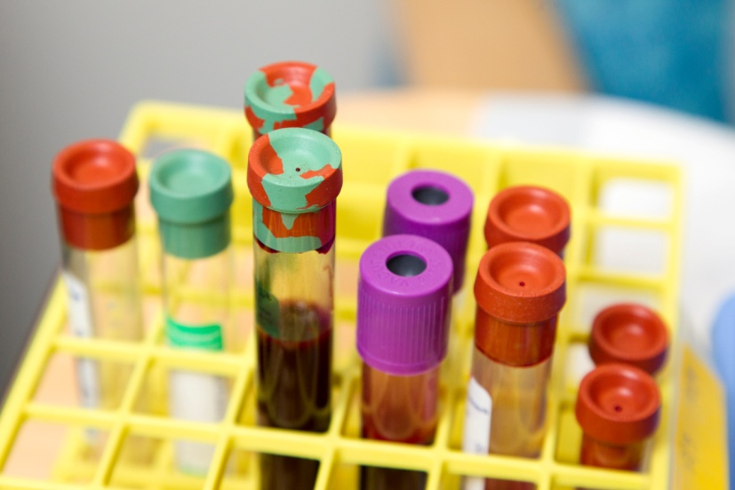

* + 1. Background

Before making any project we should have the knowledge about the nature of the project and the way it currently operates. The detailed information helps us to make this project in a systematic and in a proper way.

To do this project we should have proper concept and knowledge of coding through HTML, CSS and JAVA SCRIPT. And also about the blood bank facilities like how to donate blood and find donors.

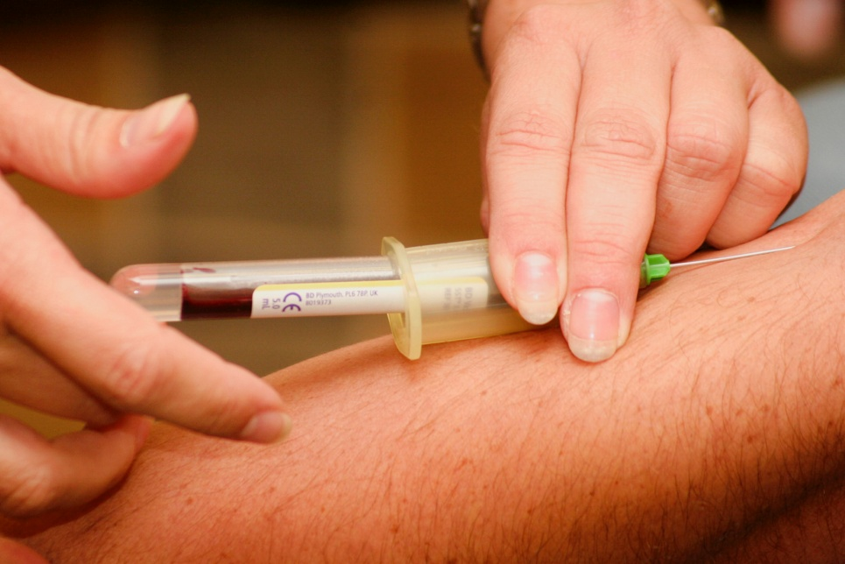

1.1.2 MOTIVATION

We have visited the hospitals several times and also read much news and heard for the need of blood. In hospitals blood is readily available for patients whenever they need for emergency; sometimes unfortunately we have the shortage of specific blood group. By this website we are able to find donors for emergency purposes and blood reserves so that we can save life.

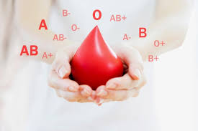

* 1. Outcome of Project

1.2.1 Concrete goals

* Easily access for finding blood donor
* Easy access to donate blood
* Friendly user interface so that everyone can understand
* At the time of emergency in hospitals individual can get blood as soon as possible

1.2.2 Objectives

* To provide interface for blood donation
* Less paper work
* Quick access to information
* To save life



1.2.3 Scope

1) Hospitals

2) Clinics

3) Labs

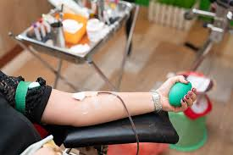

2. Description of Projects

We are working on a project of creating a webpage; here we are trying to make the webpage as much interactive and attractive so that a user can access it very easily. To do so we are using HTML, Java script, CSS as coding language.

* SIGN IN PAGE

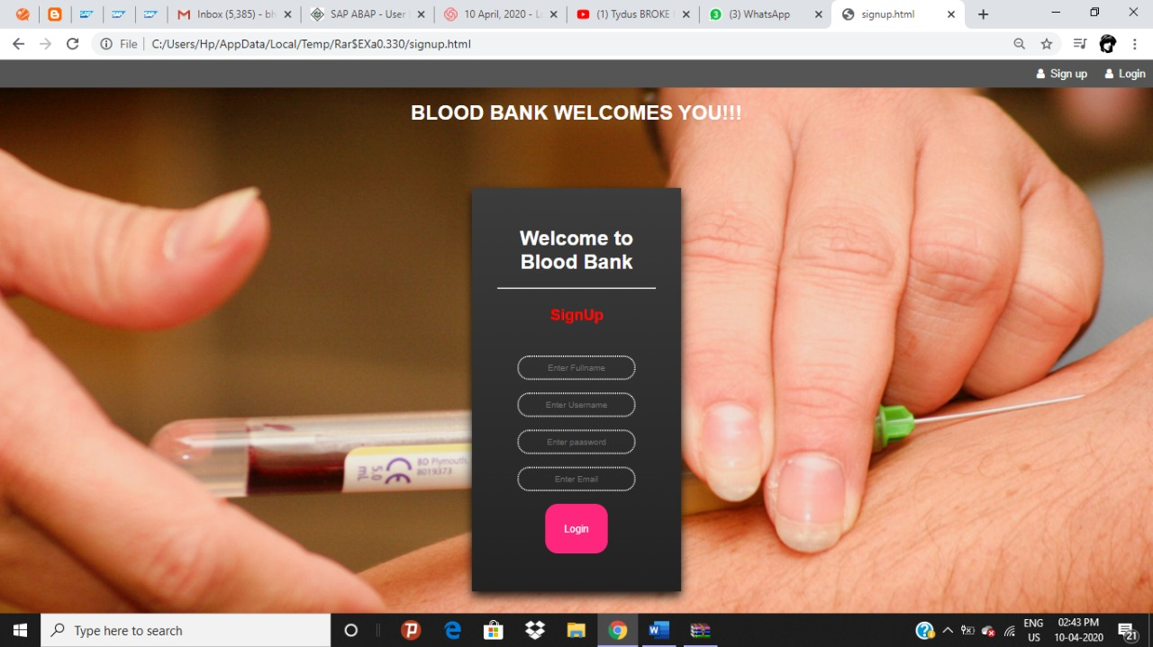

* LOG IN PAGE

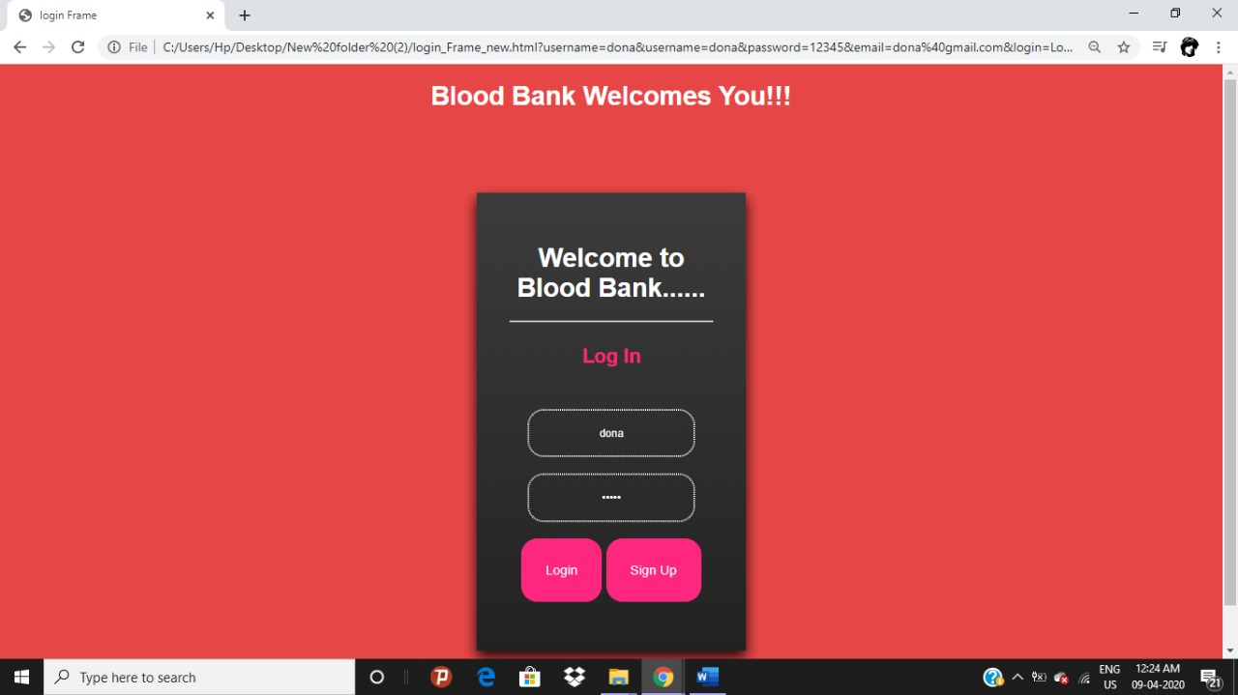

* DONOR DETAIL INTERFACE

1. Find donor – For finding a donor of specific blood group.

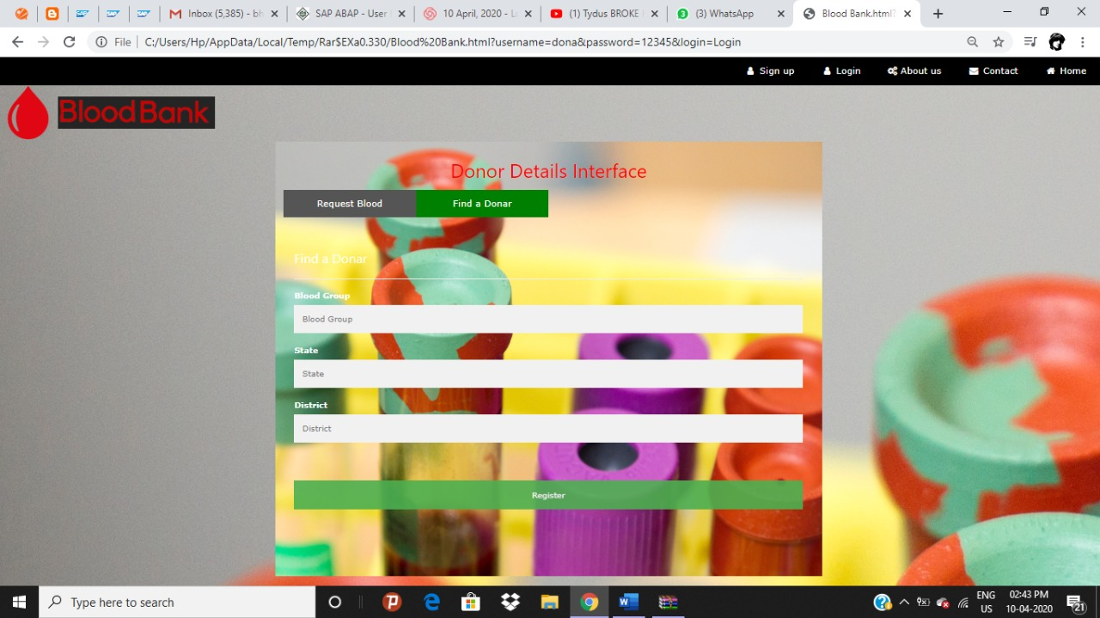

1. Request blood – donating blood.

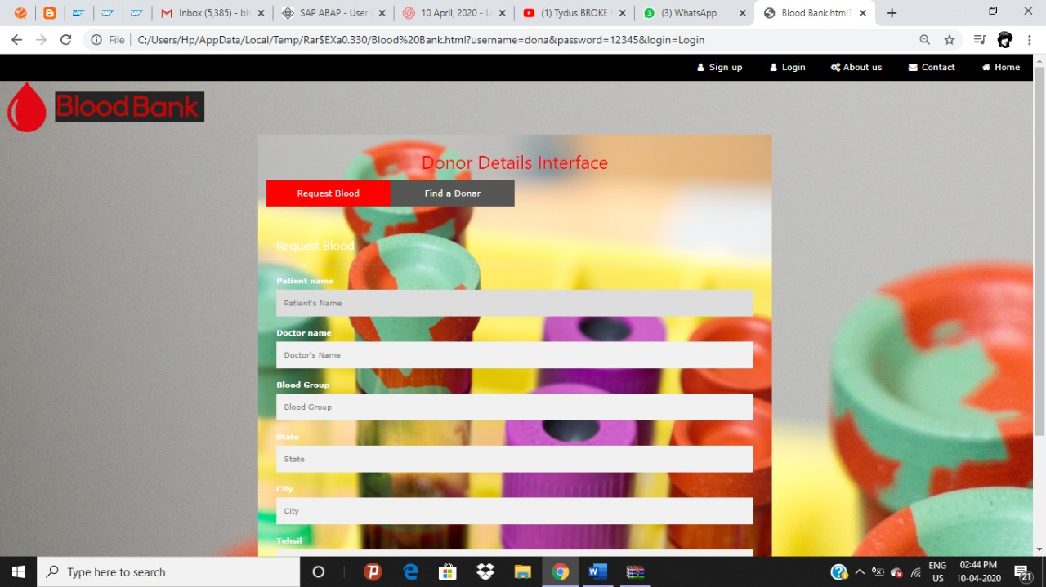

* ABOUT BLOOD BANK LINK – information about blood bank.

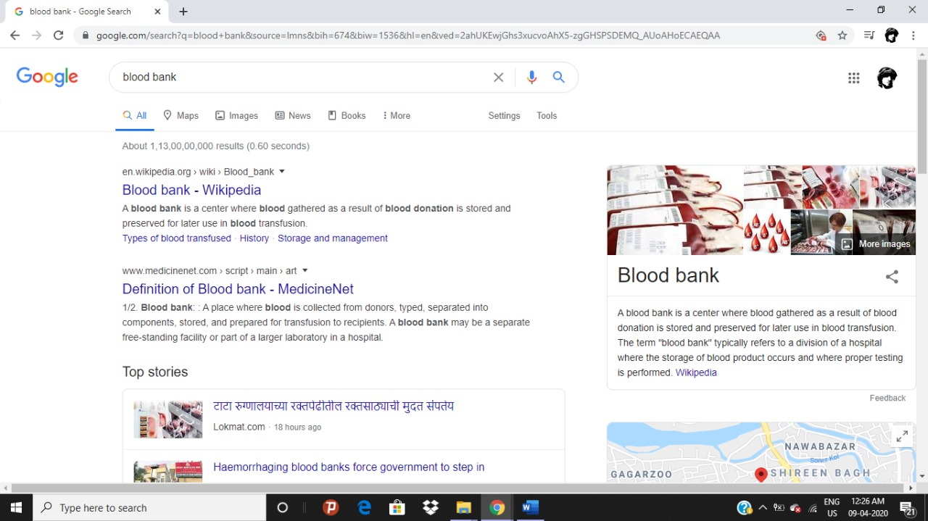

* CONTACT US TAB- contacts of various zones.

1. North zone

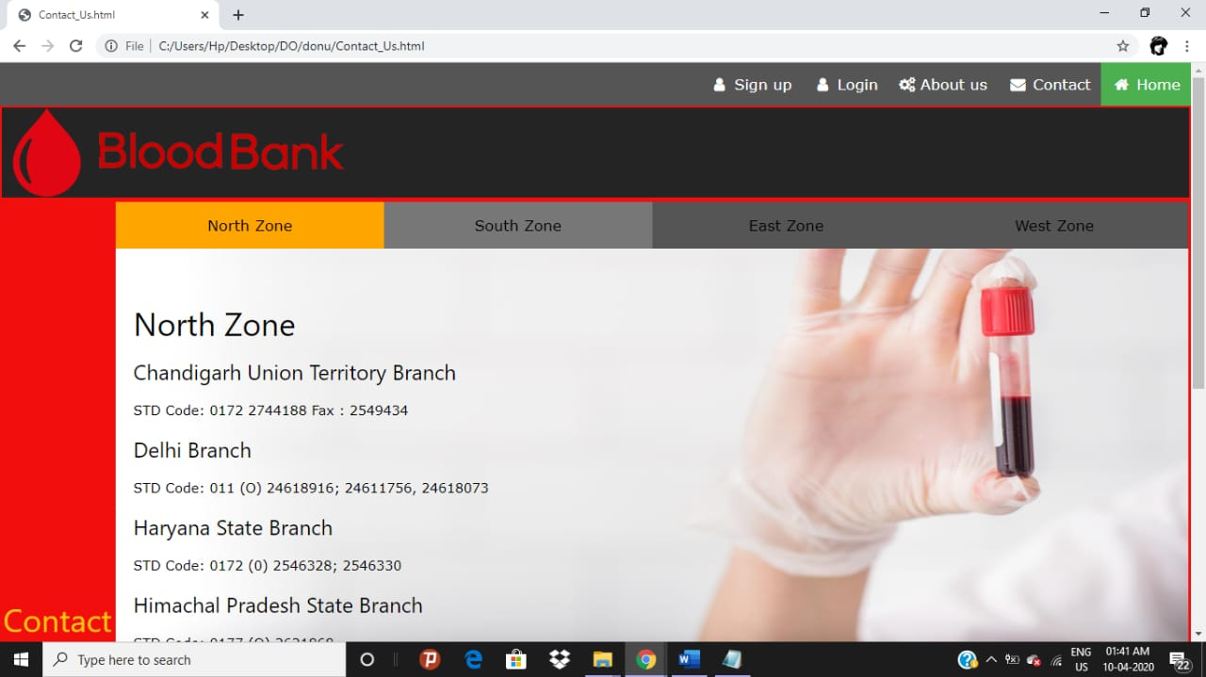

b) West Zone

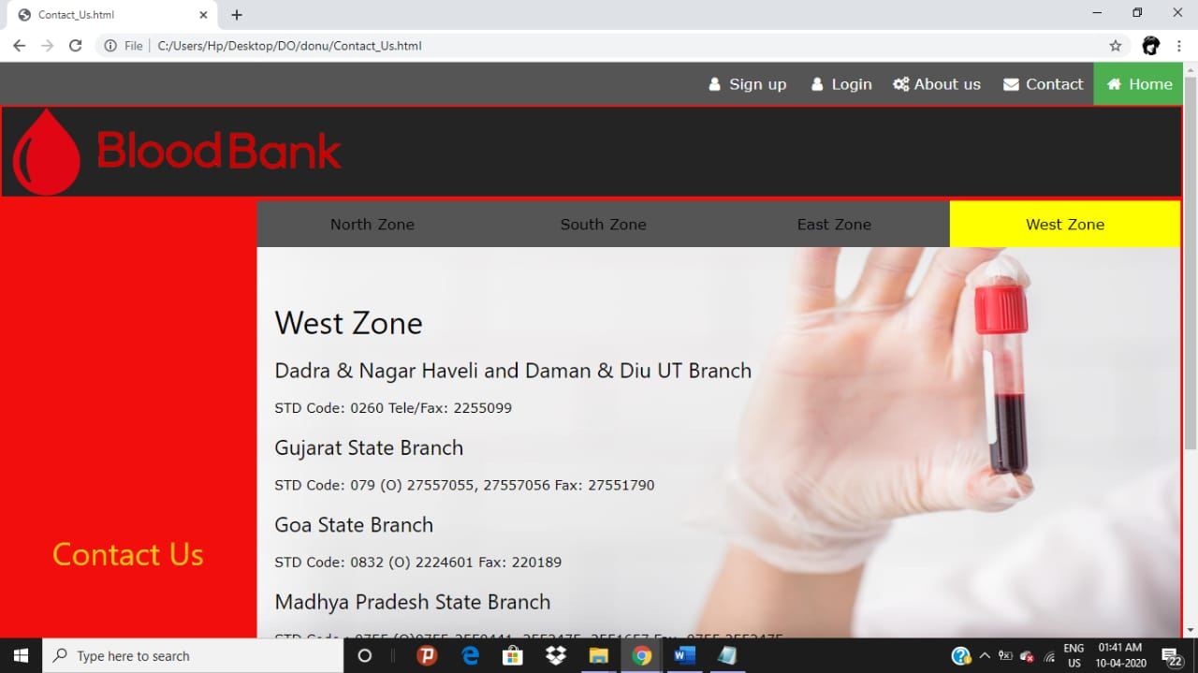

c) East Zone

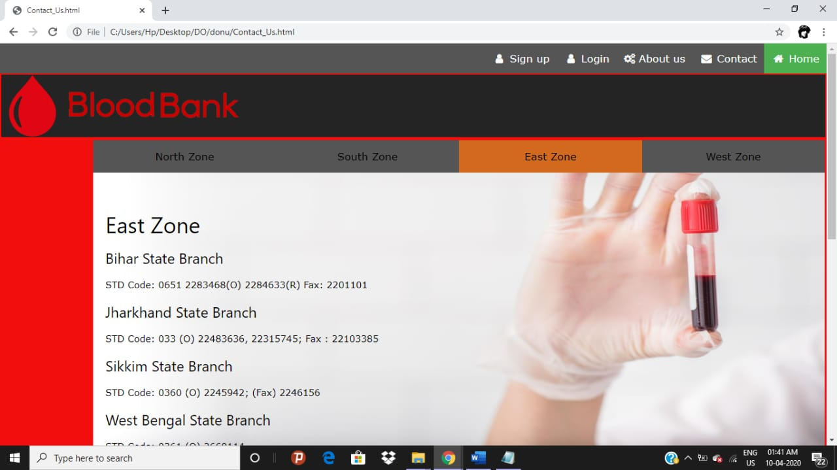

d) South Zone

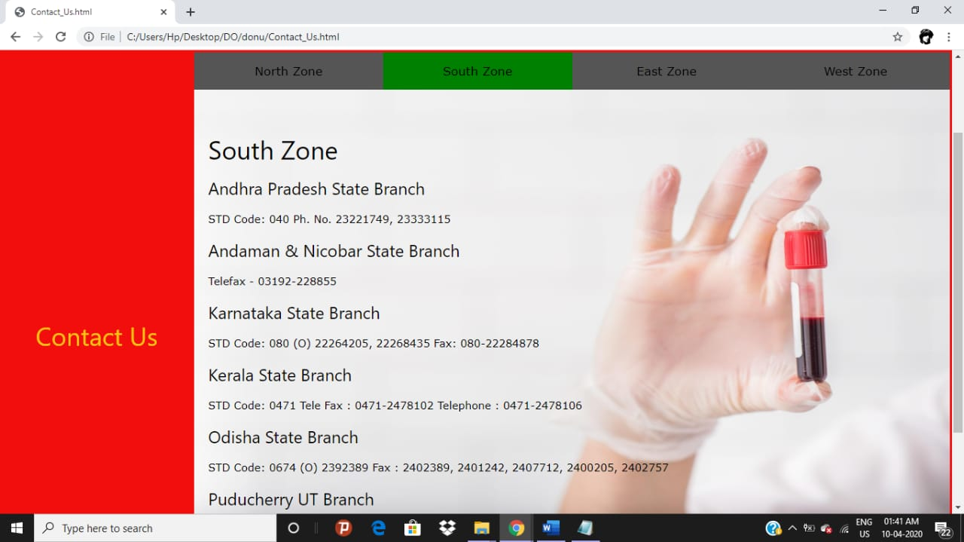

* ABOUT US

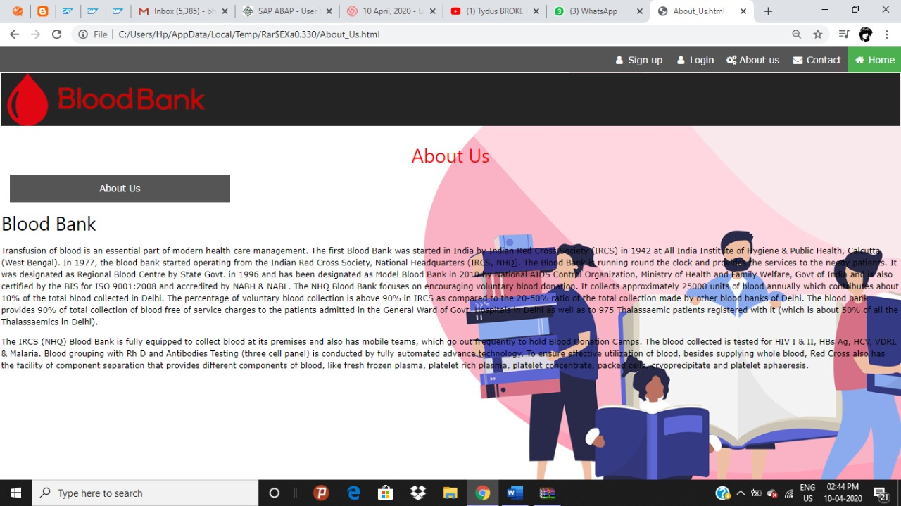

2.1 Contribution of Student

1. Dona Upadhyay (27) – Worked on the structure and the format of the webpage, coding through HTML, Java script and CSS, made final Report and Synopsis of the project, prepared loom video.

2. Kamal Nayan (26) – Worked on the styling of the elements of the webpage through CSS.

3. Narendra Sharma (25) – Worked on coding through HTML.

2.2 Technology and Framework

We used following Technologies:

1) HTML

2) JavaScript

3) CSS

4) User Interface

2.3 SWOT Analysis achieved in Project

1. We all learned about the basic working of HTML, CSS and JAVA SCRIPT.
2. We all learned about the hospitality services of Blood Donating Hospital.
3. We learned about of functioning in a group.